Abstract Template of ICFP 2025

Tony Johnson, San Zhang*

State Key Laboratory of Fluid Power Components and Mechatronic Systems, School of Mechanical Engineering, Zhejiang University, 866 Yuhangtang Road, Hangzhou, Zhejiang 310058, P. R. China

* Corresponding author: Tel.: +86-571-87952274; E-mail address: [icfp2025@zju.edu.cn](mailto:icfp2025@zju.edu.cn)

**Abstract**

This document provides authors with guidelines for composition of conference papers for ICFP 2025 in Hangzhou. The layout of this document is based on the format guidelines for the conference proceedings. You can download this template at [www.icfp-2025.org](http://www.icfp-2025.org), the official ICFP conference website. For your submissions, please use this file, which contains the official format template. Margins and format templates described in the file will automatically be defined if you use the pre-defined styles. Pre-defined styles always start with the ICFP. No further formatting or inserting of line breaks is necessary in order to stay within the margins. A graphical abstract of the conference paper is needed in the file. The graphical abstract is a visual summary of the main findings or essence of the paper. It includes images, diagrams, or figures that convey the key message of the research in a clear and concise manner. This visual representation helps readers quickly grasp the core concepts and results of the study without having to read the entire text. Please see the example below. *(The abstract should be* *at least 300 words.)*

Keywords: Layout, Template (The keywords should contain maximum 5 words.)

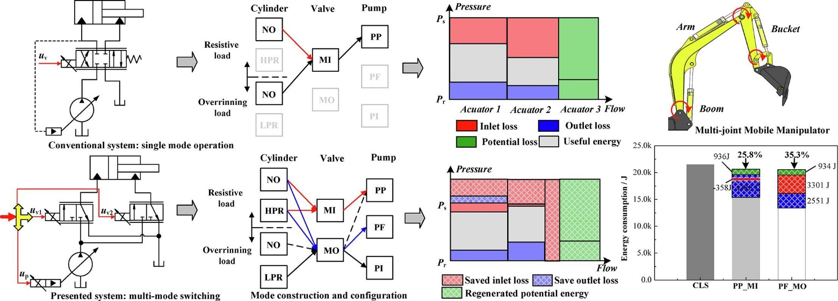

Figure 1 The layout and experiment results of the multi-mode switching system